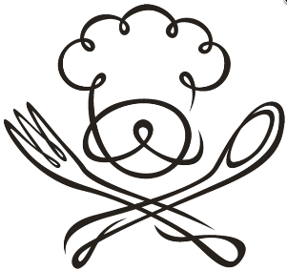
Culinary Club
Monthly Theme and Menu
Month Cost Theme Menu u
August $4 After School Snacking English Muffins 3 ways
September $4 Breakfast for Dinner Flaw (pancake soufflé) and fruit salsa
October $5 Spooky Treats Mummy Dogs, Caramel Apple Nachos, & Phantom Fanta Floats
November $4 Fall in love with Fall Pumpkin Cookies with browned butter icing & Apple Crisp
December $5 Keeping it Cozy Taco Soup and Corn Muffins
January $4 Heart Healthy New Year Peanut Butter Chocolate Chip & Coconut Pecan Chocolate Chip Granola Yogurt Parfaits
February $4 Valentine’s Day Frosted Sugar Cookies and Ladybug Strawberries
March $4 Fiesta Churro Chex Mix & Mexa S’mores
April $6 Dinner for the Family Baked Ziti, Italian Salad & Garlic Bread
May $6 Mother’s Day Cake Decorating (Cake for MOM)
Specific dates will be posted the month prior to the cooking session. Prices are determined by the cost of the ingredients.
Please pay Mrs. Curry in Room 2107 at least 2 days prior to each cooking session. See Mrs. Curry or Mrs. Malone with questions.

